

Project Report
Lost&Find.com– A PHP Website

Summer Internship Program – June-July 2016

Submitted by:
Mukesh Kumar Srivastava
Sr. No.: 530/14
B. Tech. Final Year [C.S.E.]

Acknowledgement

With immense pleasure, I would like to present this project report as my summer training project. It has been a great experience for me to complete the project entitled Lost&Find.com- A PHP Website. I would like to express my sincere thanks to all those who helped us during this project.

First of all, I am worth integrating the project mainly due to my friends and guides , without whose support it would have been impossible to prepare the project. I am not worth thanking them, but still the project work is the manifestation of the efforts and confidence they have invested in us.

Secondly, the support extended by the Peers Group , StackOverFlow community is on the one hand commendable and on the other hand unspeakable. In the college life, friends always played a vital support in terms of the realization of my strengths and weaknesses by me. They supported me when I used to feel low and felt happier and more zealous than me every time I succeeded.

Words are insufficient to express my gratitude in presenting this project to you as I have done solely my best to make this project beautiful.

Mukesh Kumar Srivastava
Sr. No.: 530/14
B. Tech. Final Year – [C.S.E.]
Harcourt Butler Technological Institute

Abstract

The project Lost&Find.com – A PHP WebSite is a web engine program that provides a support in order to find some unknown , Lost things .. The people who have found some irrational , unknown , somehow Lost things(without an owner ) can post about that thing on Lost&Find , and the people who are looking for their lost stuffs to find that , they can search here and get to know if their stuff is here .

The web interface front end has been programmed in HTML5 , CSS. The main navigation bar provides four main modules of Lost&Find , that is News , Post , Search , Status . All Modules are dependent to each other in order to support more exploration . The News system has been programmed to provide date wise Articles in descending order. An authentication system allows an A known user – a contributor to the Lost&Find privileges to set his profile and keep tracking of all his/her himself own records as a Contributor . The articles in each newscore are rendered according to the scheme selected from an MariaDB (MySQL) database in the backend.

In the end, the complete project was a valuable learning experience that I will be able to carry with me in future work. The level of exposure and the mindset to the project work that I got during making of the project is, in my opinion, incredible and, at the same time, hysterical.

Table of Contents

Serial | Contents | Page
1 | Introduction | 5
2 | Future Scope | 6
3 | Project Working Details & Screenshots
3.1 | Home and Post Module | 7
3.2 | Search and Status Module | 8
3.3 | Anonymous user and about us Module | 9
3.4 | User Sign in / Sign Up System | 10
5 | Evaluation | 11
6 | Conclusion | 13

Introduction

The project has a front end – a Web Interface for a candidate written in HTML5 , CSS3 and a back end – an MYSQL Database that contains all the User Details , Lost Data Records , Date Records .

The web interface front end has been programmed in HTML5 , CSS. The main navigation bar provides four main modules of Lost&Find , that is News , Post , Search , Status . All Modules are dependent to each other in order to support more exploration . The News system has been programmed to provide date wise Articles in descending order. An authentication system allows an A known user – a contributor to the Lost&Find privileges to set his profile and keep tracking of all his/her himself own records as a Contributor .

It contains a navigation bar at the top in which there are modules listed here : Home , Post , Search , Status , About Us .
Home : - It shows all the found stuffs which is unknown to their owner . It shows data in descending order in dates when the things were found.
Post : - Here User can post all the details about the stuff which he has found including Photo , The person who has found the item , Contact details , Contact Address , Name , Description of the item .
Search : - Here User can Search about the item on the basis of Item name , Location where the item was lost, Date when the item was lost . If any basis is matched with the data which is already there .
Status : This is like a Profile page with the intention to realize user for his contribution to the lost&find and We are Thankful to him for this . It shows Signed User Profile Data like Name , Contacts , Age , Gender , bio( A short Description about the user what he has written himself ).
Below this , It includes The Data which he has Contributed .
About Us : -It’s all about us . Our vision , approach .

Future Scope

As the project is developed further, it can be used for a variety of applications. But still It needs improvement over many features and some extensive features to enhance the system and a better step to the vision of the System .

There are certain limitations like :
- No Authentication of Confidentiality and originality of the Data.
- Once User has posted / Contributed , It can’t manipulate it’s own article even after the return of the item .
- There is no Notification provided about the item that it’s has been returned.
- Contributor has no control on the article after Post about the item.
- No search mechanism for the Contributor

We are in Process of reducing the no. of limitations as soon as possible.

If we talk about further enhancement , there are future extensions for the enhancement of the System listed here which can be implemented :
- Image recognition search of the item .
- As like Post , There can be a Lost Module where user can report about a lost item and if that item is found there on matching of the Item’s Image or Date or Location Basis , It can also generate a list of the nearest possible Items.
- Communication System between users for Increasing Reliability among users .
- Contributor can also have some track of Thanks or Upvotes for the Contribution , He/ She should be honored on the his status page.

Project Working Details & Screenshots

Home
Home navigation is the main and first element of the nav bar which allows the user to look through all the found items one by one according to the posting dates in descending order.

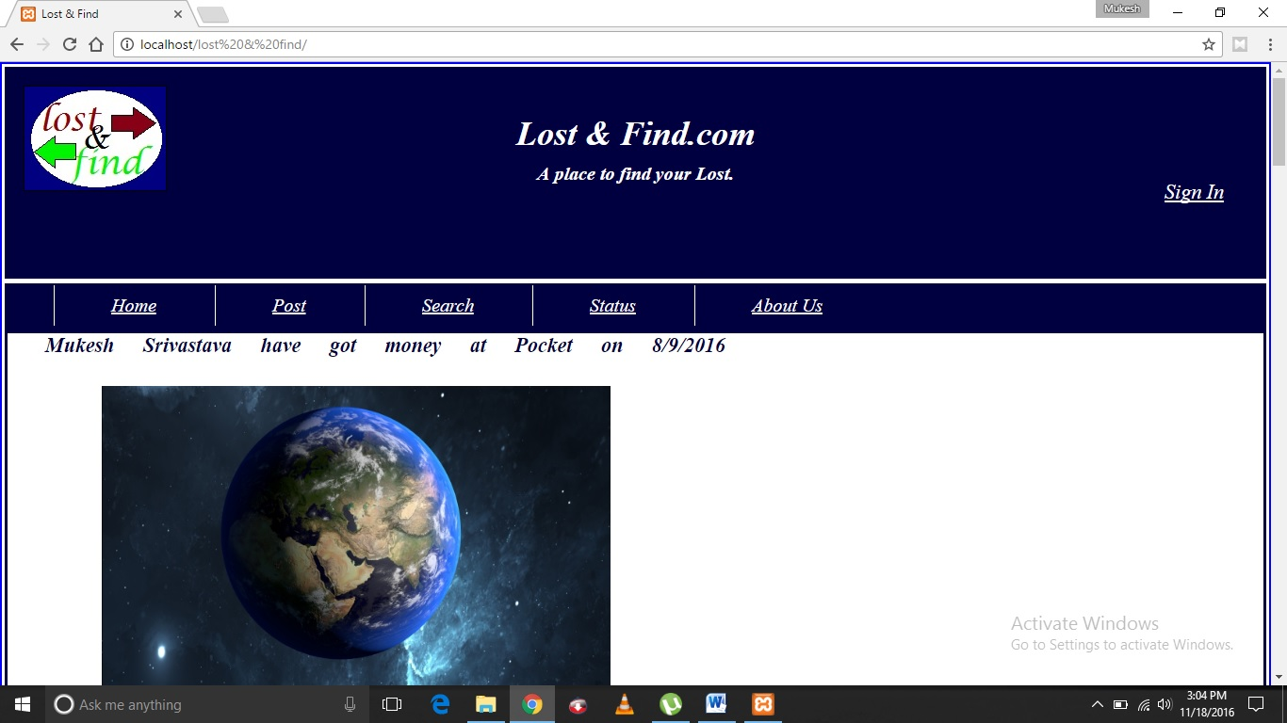

POST
In Post navigation , There we can post /contribute if we have found any unknown stuff which owner is not known . It’s a form which allows one to post all the relevant information about the project .
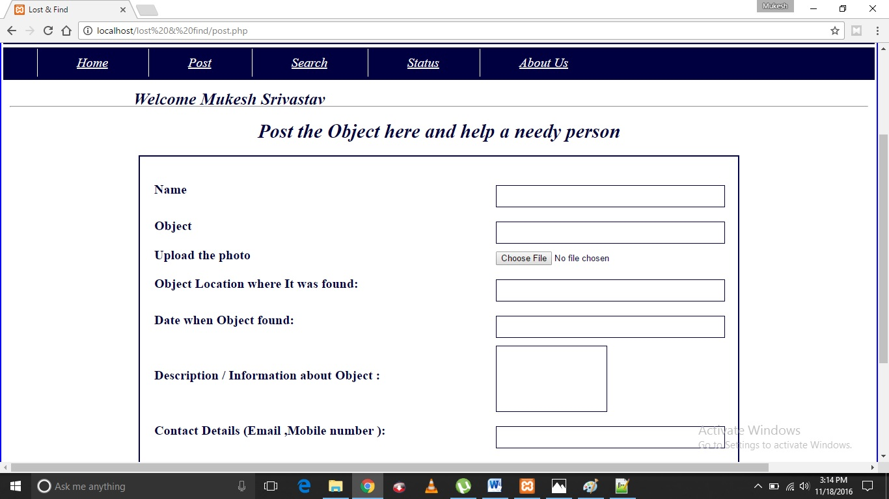
SEARCH
In Search navigation , There we can search the item after giving the input text what we are searching and after giving the basis to search . If there is any item similar to the search text found in the relevant basis column in database , then it will return all the detailed description of item.

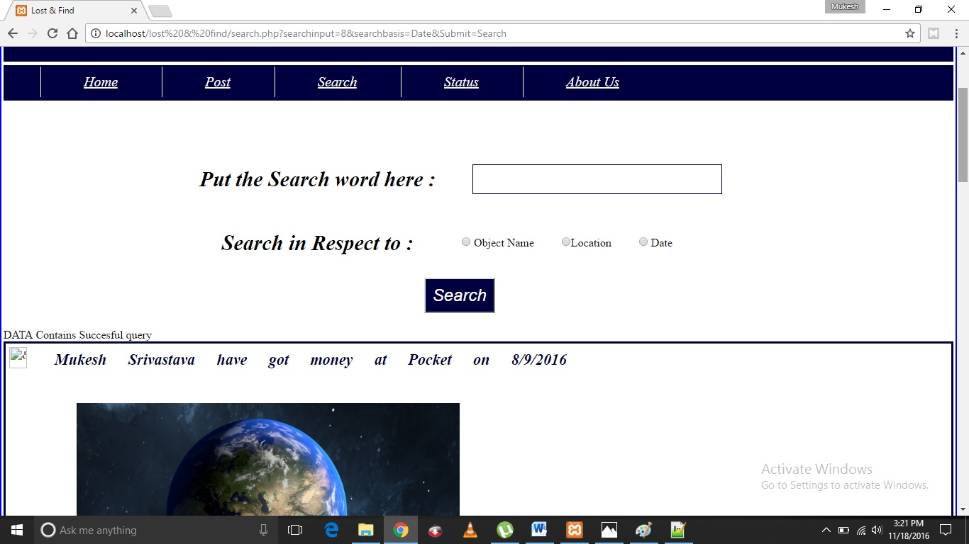

STATUS
In Status navigation , There if the user is known user ( after sign in it is redirected to here ), only then it wil show the user’s profile information and it’s posted items . Otherwise it will show as Anonymous user sign .

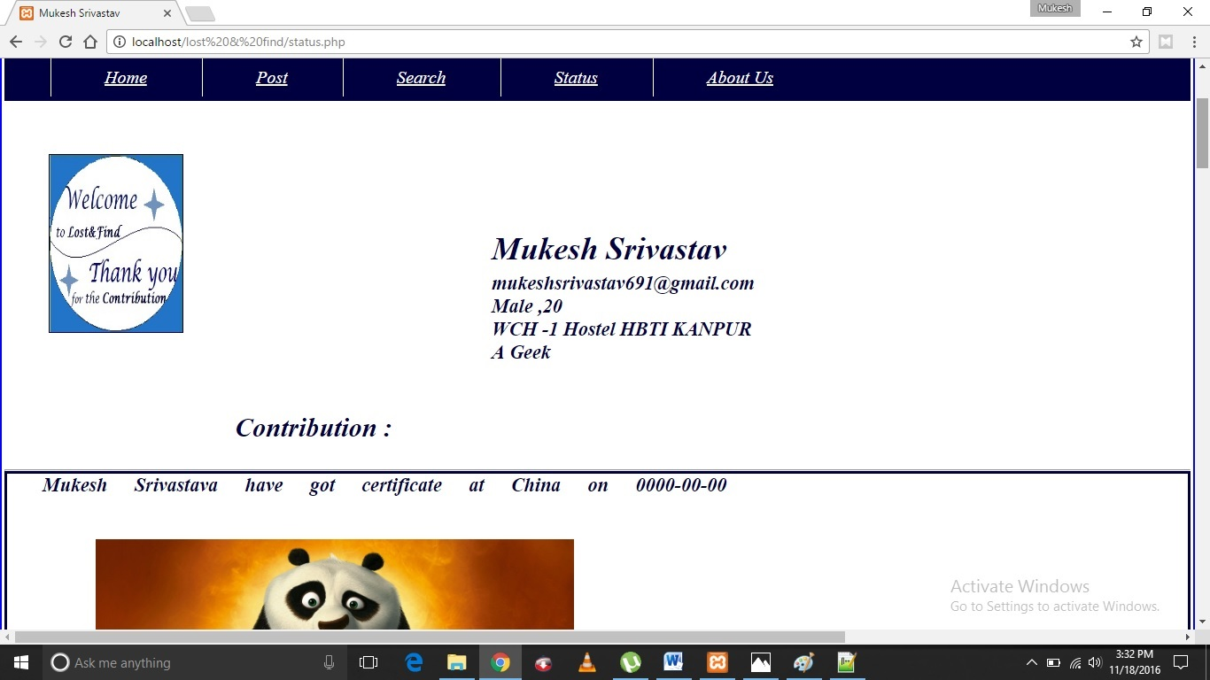
Anonymous user

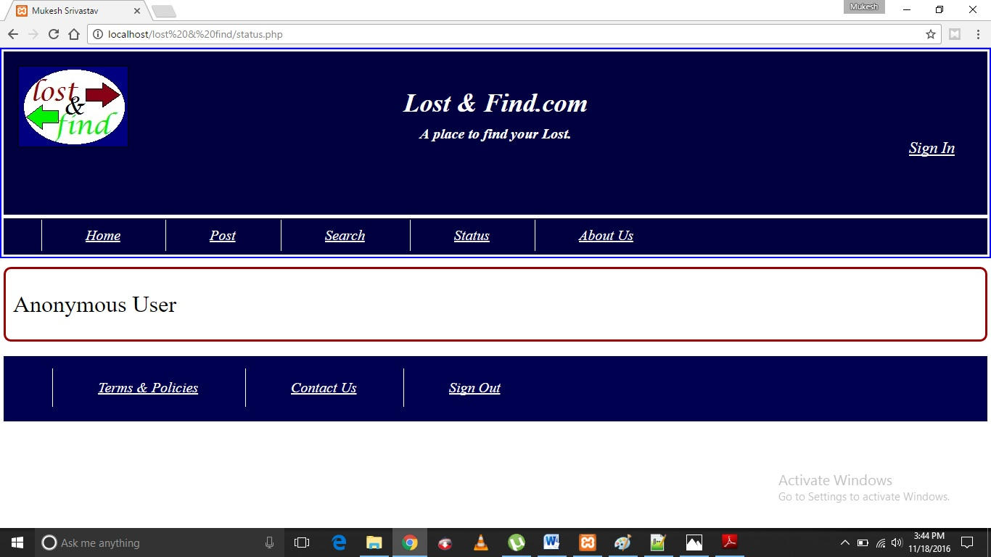

ABOUT US :
In this navigation ,It is always static irrespective to whether user is signed in or not . It shows introduction of us , our approach behind this .

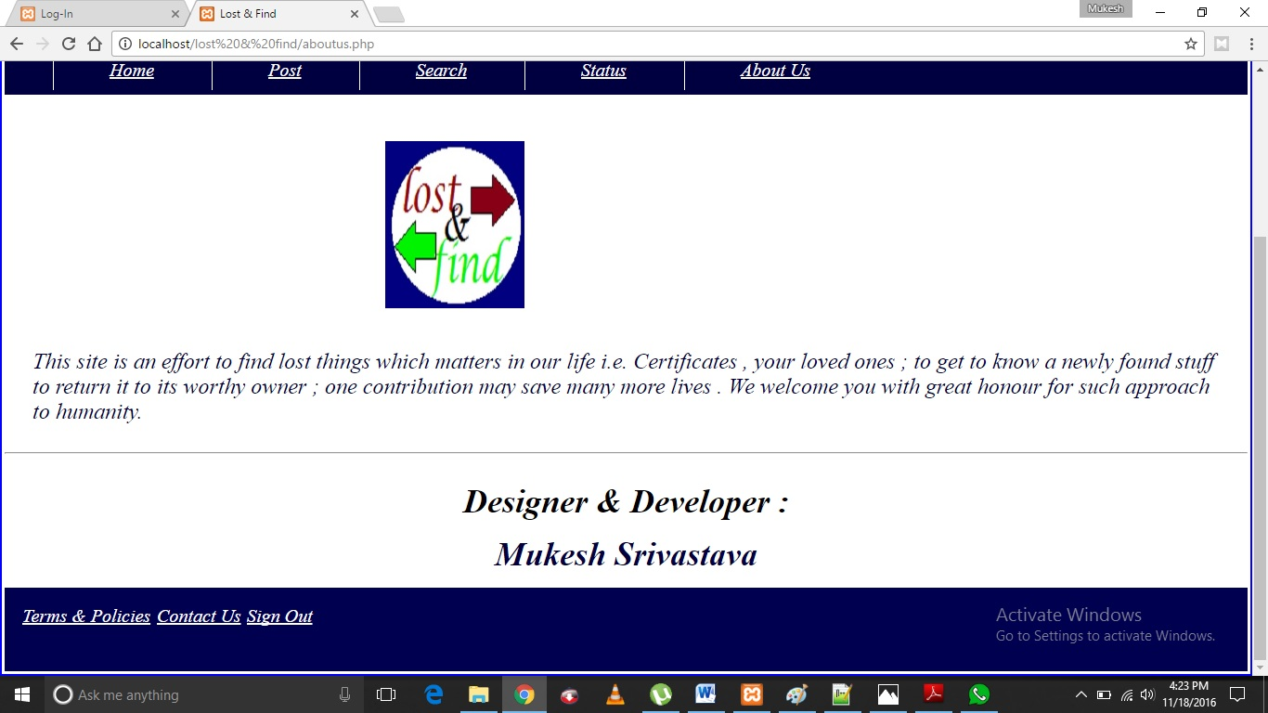

SIGN IN
Here Users can Sign in / Log in and track record of their contributions using their Email and Passwords provided during Sign Up Process . If there is no account of one then there is a link to sign up page provided below submit button. If user is authenticated as known , then it would be redirected to status page .
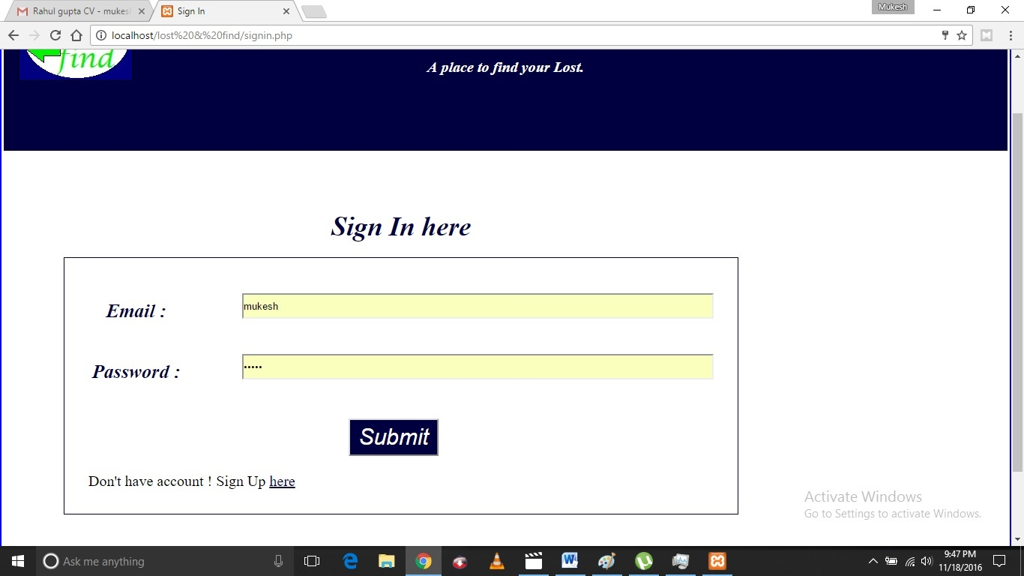
SIGN UP
In this , New User can provide it’s information and be a new member of this community , It is simple and must requires all the fields to fill completely . If You signed up successfully , it will show a message of sign up successfully , and ask you to sign in.

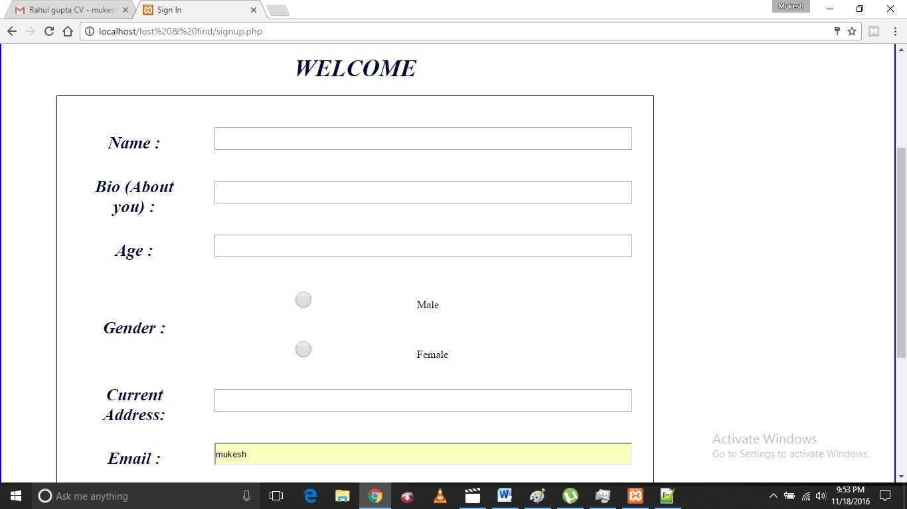

Evaluation

Final Project
This project is an genuine work on itself hypothetically, and I have tried best to make it come true. The idea behind this project is that to provide you a platform for looking up the items which unknowingly get lose and we needed it back . Also this Platform allows other users to post about the items to continue the process. It was not a easy journey to implement my own idea to work and perform all roles for the project , Designer , Developer , Testing , managing . It was completely full proof learning experience and making my own thought to digitalize. I know there are various features which can be built into this. And I will try to avail those features. I have implemented less as only basic features yet it needs to contain more extension which provides it more future scope for such type of website . Also this Website is in itself a unique way to automate those old “Khoya-Paaya Centres” in our towns. This website can be used by a large domain of people like Police , Hospital Staff , More Public Places controlling staff , as well as normal people too .

Development Project
The whole development process was new to me. I had to figure out the best way to approach every situation. Though, at first it took a while to figure out how to approach the project, now I have a pretty good understanding of how to prepare for big projects like this one. I don’t think it’s possible to spend too long planning a project, because little snags always pop up. The more you plan out, the easier it will be when these little surprises happen. I thought I had planned a lot – especially for a lot of the issues that occur because of different browsers, platforms, and monitor resolutions. Often in class I put projects up for review half-finished and get comments about things I already knew were wrong. At the end of this project I feel a lot more prepared to take on a big design project by ourselves again. Because I was not given a certain process or plan to follow with this project and I had to figure out a process of our own to follow.

Experience
This training-cum-internship experience has been invaluable as I have gained some incredible real world experience and built up our portfolio. I enjoyed the experience whole-heartedly because our work tasks were so varied. I was given a lot of creative freedom in our work, but sometimes I received specific design requirements. With this work I was able to experience a variety of different design tasks. I was able to start a project from concept and carry it through to completion as well as work on many other smaller redesign projects. The skills that I learned during this internship experience, it will be carried with us in work on future projects.

Conclusion

In a nutshell, this project has been an excellent and rewarding experience. I can conclude that there have been a lot I have learnt from our work. Needless to say, the technical aspects of the work I’ve done are not flawless and could be improved provided enough time for more enhancements.
After the project development, I have developed in myself a superfluous amount of self-confidence and will to learn and doing more projects. This has been the greatest advancement in me after the six weeks of the project development.
Two main things are that we’ve learnt the importance of time management skills and self-motivation. Although I have often stumbled upon these problems earlier, they had to be approached differently in a working environment.

